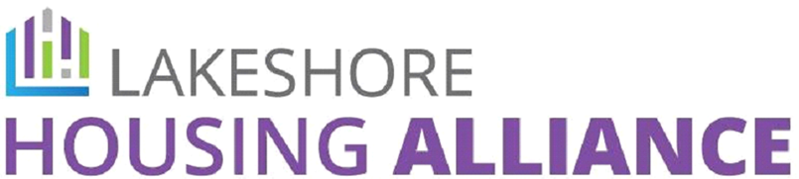

Community Values Statement

The Lakeshore Housing Alliance hosts open bi-monthly meetings for voting members and non-members alike. All are welcome. We ask that everyone participating speak to and about people with respect; be open to other perspectives; use and value trauma conscious communication; be honest; only share accurate and data driven information; and acknowledge your own thoughts and feelings as well as those of others, especially those with lived experience.

