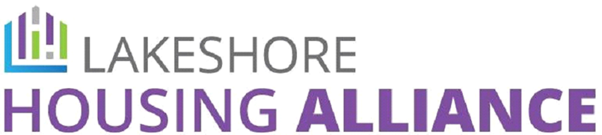

Friday August 7th, 12pm-1:30pm TEAMS (virtual only)
Introductions

LHA Community Values Statement (Copy in LHA Executive Folder)

- Approval of agenda
    - Volunteer for minutes
    - Dwelling Place presentation (Nathan Poel) Vote for LOS
    - New member discussion-Tri Cities Habitat for Humanity (Vote)
- Staff Update (Christina)
    - Fundraising update (Christina/Erin)
    - Data Updates (Jayce)
    - BNL (Brenna)
  - FY26 NOFO update*no application for Collaborative Applicant as of 8/5 (litigation-filed 6/22/26 Exhibit Proposed First Supplemental Complaint – #97, Att. #1 in National Alliance to End Homelessness v. United States Department of Housing and Urban Development (D.R.I., 1:25-cv-00636) – CourtListener.com
- CoC Update
    - Member spotlight- Reach for Recovery (Jeff Marschall)
    - Presentation-2-1-1
    - Invitation to share success stories
    - MSHDA ESG-FY2026-27 (Mark)
    - HUD FY26 Project Ranking Update (Mark)

  - Updates
    - Executive Committee (Sarah/Brenna)
    - Allocation and Accountability (Mark)
    - HMIS Agency Administrators (Jayce)
    - Housing Choice Vouchers (Brenna)
    - 2027 PIT Count Planning (Jessica)
  - Announcements
    - De-escalation Training Save the date: 09/28/2026-10am (Free training for staff-Registration coming)
    - HPE Fund application coming in September (LHA members in good standing encouraged to apply.)
  - Adjournment

Next LHA Bimonthly Meeting, Friday, October 2rd, 12pm-1:30pm Teams Meeting

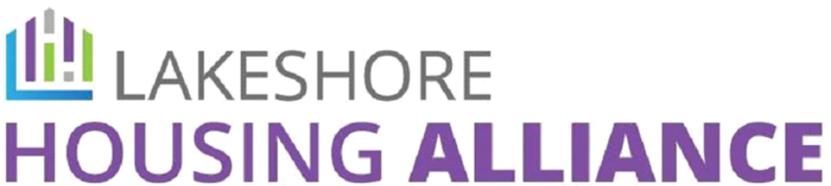

LHA Values and Meeting Expectations Statement

The Lakeshore Housing Alliance hosts open bi-monthly meetings for voting members and non-members alike. All are welcome. We ask that everyone participating speak to and about people with respect; be open to other perspectives; use and value trauma conscious communication; be honest; only share accurate and data driven information; and acknowledge your own thoughts and feelings as well as those of others, especially those with lived experience.

