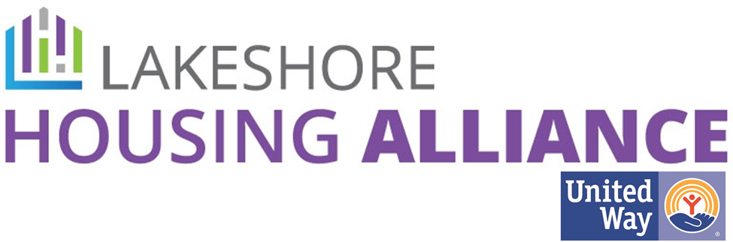

**Membership Information**

**The Lakeshore Housing Alliance (LHA) invites nonprofit service providers, government entities, businesses, and individuals to join us in our efforts to end homelessness and to provide safe, affordable housing in our community by becoming a member of LHA.**

The Lakeshore Housing Alliance serves as the Continuum of Care for Ottawa County, Michigan and is dedicated to identifying needs, developing a vision, encouraging coordination of responses, and advocating for safe, accessible, affordable housing and services.

As a member of the LHA, your organization may be eligible to:

* Apply for new and/or renewal funding from the Department of Housing and Urban Development (HUD)
* Apply for new and/or renewal funding from the Michigan State Housing Development Authority (MSHDA)
* Apply for funding from the Homelessness Prevention Endowment
* Participate in specialized trainings and workshops for members only when they become available

Our organization’s membership also supports:

* The implementation of the Plan to End Homelessness and the fulfillment of its goals and objectives
* Events that raise awareness about the needs of the homeless in our community
* The infrastructure of the Continuum of Care
* Networking and Collaborative partnerships

To join the LHA please complete the enclosed membership form, and once signed by the organization’s executive director, and return it to:

Christina Fort, LHA Director

For more information on the LHA please visit <https://www.goodsamottawa.org/lha>

To join the LHA, please complete the enclosed membership form, have it signed by the organization’s Executive Director (if applicable), and return the completed membership form to:

Christina Fort

[Lha@goodsamottawa.org](mailto:Lha@goodsamottawa.org)

ORGANIZATION (N/A if applicant is an individual) _______________________________________________

ADDRESS: ______________________________________________________________________________

CITY _______________________ STATE __________ ZIP ___________ FAX_____________________

PHONE__________________ WEBSITE: ______________________________________________

**Continuum of Care Contacts & Responsibilities**

Please identify one primary and, if applicable, alternate contacts from your organization to be the contacts for the Continuum of Care. These are the individual(s) who will have the following responsibilities:

1. Regularly attend the LHA bi-monthly membership meetings the first Friday of even months, 12:00 PM on Zoom or at the Fillmore Complex in West Olive unless otherwise indicated.
2. Actively participate in a sub-committee or ad-hoc committee as able.
3. Communicate back to their own organization and/or community, as appropriate, information shared at the membership meetings, events, and/or through e-mail communications.
4. Regularly participate in LHA-sponsored events including but not limited to the Point In Time Count, trainings, etc.

**PRIMARY CONTACT NAME**________________________________________________________________

* Check here if same as address above

ADDRESS_______________________________________________________________________________

CITY ________________________ STATE __________ ZIP ___________

FAX_____________________

PHONE__________________ E-MAIL (please print clearly) __________________________________

**ALTERNATE CONTACT NAME** _____________________________________________________________

* Check here if same as address above

ADDRESS_______________________________________________________________________________

CITY _____________________ STATE __________ ZIP ___________ FAX____________________

PHONE__________________ E-MAIL (please print clearly) ___________________________________

SIGNED: _________________________________________ DATE: ________________________________

(Organization’s Executive Director, if applicable)