This document provides instructions for completing the Point-In-Time (PIT) Homeless Count 2024 Data Collection Form.

**Introduction**

The **Data Collection Form** includes the required data elements collected during the PIT Count. The form can be used for an unsheltered count, non-HMIS Emergency Shelter projects, and non-HMIS Transitional Housing Projects. The **Data Collection Form** meets the minimum data collection requirement for submission of the PIT report to HUD. Communities can decide locally to include additional fields during the count.

It is imperative that information collected during the count is accurate, reliable, and complete. Follow local guidance for conducting a thorough and safe count. Use the definitions and instructions within this document to complete the Data Collection Form for each individual encountered during the count. Use abbreviations or codes as necessary when completing the forms.

If information is not captured during the PIT interview, do *not* presume someone’s identify or experience. Use data not collected, client prefers not to answer, or client doesn’t know options. System Administrators will need to use community estimations to complete missing information for PIT submission.

If you are a Domestic Violence Agency project STOP HERE. Refer to the Michigan 2024 PIT Count Data Collection Form Instructions for Domestic Violence Agencies for guidance.

**On forms containing multiple households, single adults, and/or unaccompanied youth separate each household, single adult, and unaccompanied youth with a blank line. See example below.

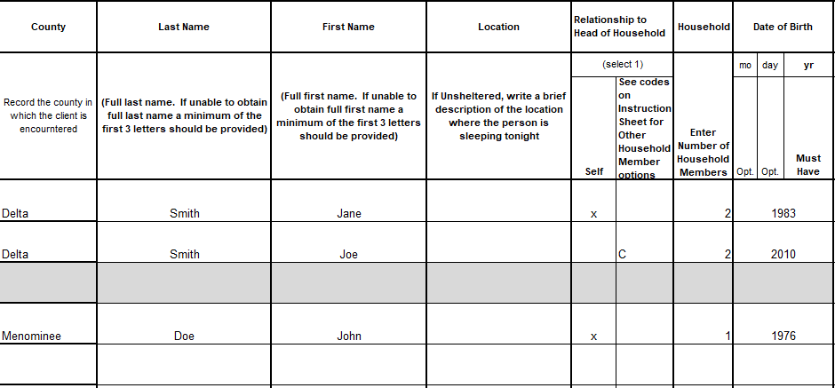

**Date Completed:** The date the form was completed. This may be the date of the PIT count or day after count.

**Name of Person/s Completing the Form:** Add the names of each individual completing the form.

**Type of Count:** Add a checkmark next to the type of count that is being conducted. Include the Project Name for **Non-HMIS Emergency Shelter (ES)** projects, **Non-HMIS Transitional Housing (TH)** projects, and **Other** projects. Add the **Location** for **Unsheltered** counts.

**County:** Record the county in which the client is encountered or sheltered.

**Last Name:** Enter the individual’s full last name. If the full last name cannot be collected, include at least the first three letters.

**First Name:** Enter the full first name here. If unable to provide full first name,please include at least the first three letters.

**Location:** Add a location for persons that are unsheltered. This may include an address or cross-streets. Leave this field blank for all other projects.

**Relationship to Head of Household (HoH):** Mark **Self** for single adults, unaccompanied youth or the head of household. Only one person per household can be defined as **Head of Household**. For other household members use the **HH Member field** to add the relationship to HoH. Relationship to Head of Household codes include:

|  |  |
| --- | --- |
| **Code** | **Relationship to HoH** |
| **C** | Head of household’s child |
| **S** | Head of household’s spouse or partner |
| **OR** | Head of household’s other relation member |
| **Other** | Other: non-relation member |
| **DNC** | Data not collected |

**Household:** Enter the number of individuals surveyed in the household. This number will be the same for all household members. Ex: If a household of 3 is surveyed, each household member would have a “3” in this section.

**Date of Birth**: Enter the date of birth for each individual surveyed. **At a minimum, the year of birth is required.**

**Gender:** Enter the gender as identified by the individual during the count. Add all applicable genders separated by commas. Contact your System Administrator for more information regarding gender identity definitions. Use the following to indicate which gender the client identifies as:

|  |  |
| --- | --- |
| **Code** | **Gender** |
| **M** | Man (Boy if Child) |
| **W** | Woman (Girl if Child) |
| **CS** | Culturally Specific Identity |
| **TG** | Transgender |
| **NB** | Non-Binary |
| **Q** | Questioning |
| **DI** | Different Identity |
| **DK** | Client Doesn’t Know |
| **R** | Client Prefers Not To Answer |
| **DNC** | Data Not Collected |

**Race and Ethnicity:** Enter the race and ethnicity as identified by the individual during the count. If collecting information on a person with multiple responses separate each race using a comma. (ex: White, Asian). Use the following to indicate which race and ethnicity categories the client identifies as:

|  |  |
| --- | --- |
| **Code** | **Race** |
| **A** | American Indian, Alaskan Native, or Indigenous |
| **B** | Asian or Asian American |
| **C** | Black, African American, or African |
| **D** | Hispanic/Latina/e/o |
| **E** | Middle Eastern or North African |
| **F** | Native Hawaiian or Pacific Islander |
| **G** | White |
| **DK** | Client Doesn’t Know |
| **R** | Client Prefers Not To Answer |
| **DNC** | Data Not Collected |

**Domestic Violence Victim/Survivor:** Domestic Violence Victim/Survivor should be indicated as **Yes** if the person has experienced any domestic violence, dating violence, sexual assault, stalking or other dangerous or life-threatening conditions that relate to violence against the individual or a family member, including a child, that has taken place **within the individual’s or family’s primary nighttime residence.**

|  |  |
| --- | --- |
| **Code** | **Domestic Violence Victim/Survivor?** |
| **Y** | Yes |
| **N** | No |
| **DK** | Client Doesn’t Know |
| **R** | Client Prefers Not To Answer |
| **DNC** | Data Not Collected |

**If Yes, Currently Fleeing:** Currently fleeing should be indicated as **Yes** if the Person is fleeing, or is attempting to flee, the domestic violence situation **or** is afraid to return to their primary nighttime residence*.*

|  |  |
| --- | --- |
| **Code** | **If Yes, Currently Fleeing?** |
| **Y** | Yes |
| **N** | No |
| **DK** | Client Doesn’t Know |
| **R** | Client Prefers Not To Answer |
| **DNC** | Data Not Collected |

**Approximate Date This Episode of Homelessness Started**: Use this section to enter the date that of the client’s current episode of homelessness (staying in an unsheltered situation or in Emergency Shelter). Experiencing housing instability does not count.

**Homeless Episodes in the Last 3 Years**: Enter the number of times the client has been homeless in the past 3 years. If the information is not known use the following responses:

|  |  |
| --- | --- |
| **DK** | Client Doesn’t Know |
| **R** | Client Prefers Not To Answer |
| **DNC** | Data Not Collected |

**Number Months Homeless in the Past 3 Years:**  Count total months on the street or in Emergency Shelter for the past 3 years and enter it here. If the individual reports that they were homeless for one or more days in a given month, the individual is considered homeless that month.

Example: If the individual reports that they were homeless beginning in November but do not remember the exact starting date and are still currently homeless in January this person would have experienced homelessness for 3 months.

If the information is not known use the following responses:

|  |  |
| --- | --- |
| **DK** | Client Doesn’t Know |
| **R** | Client Prefers Not To Answer |
| **DNC** | Data Not Collected |

**Disability Condition:** Enter Yes or No to whether the client have a disabling condition. Use the following to indicate is the client has a disabling condition:

|  |  |
| --- | --- |
| **Code** | **Does the client have a disabling condition?** |
| **Y** | Yes |
| **N** | No |
| **DK** | Client Doesn’t Know |
| **R** | Client Prefers Not To Answer |
| **DNC** | Data Not Collected |

**Disability Type:** Enter the disabilities as identified by the individual during the count.

Use the following to indicate the response for each disabling conditions the client identifies:

|  |  |
| --- | --- |
| **Code** | **Disability Type (Serious Mental Illness, Alcohol Use Disorder, Drug Use Disorder, HIV/AIDS)** |
| **Y** | Yes |
| **N** | No |
| **DK** | Client Doesn’t Know |
| **R** | Client Prefers Not To Answer |
| **DNC** | Data Not Collected |

**Veteran Status**: Indicate the client’s veteran status here. This population category includes adults who have served on active duty in the Armed Forces of the United States. This does not include inactive military reserves or the National guard unless the person was called up to active duty.

**If client is a veteran,** please check the corresponding box that represents type of service.

**If not a veteran**, leave this section blank.

If you have any questions about the material covered in this document, please contact the MCAH help desk at [mihelp@mihomeless.org](mailto:mihelp@mihomeless.org) (MI) or [nchelp@nchmis.org](mailto:nchelp@nchmis.org) (NC).