This document provides instructions specifically for DV Shelters completing the Point-in-Time (PIT) survey.

**Introduction**

The PIT survey contains the **MINIMUM** information **REQUIRED** by HUD. Missing or incomplete data negatively impacts the information provided to HUD regarding the homeless situations in our communities. It is imperative to complete each survey to the best of your ability.

Please use the definitions/descriptions below to fill out the PIT Survey correctly and completely for each person encountered during the count.

**For forms containing multiple households, single adults, and/or unaccompanied youth separate each household, single adult, and unaccompanied youth with a blank line. See example below.

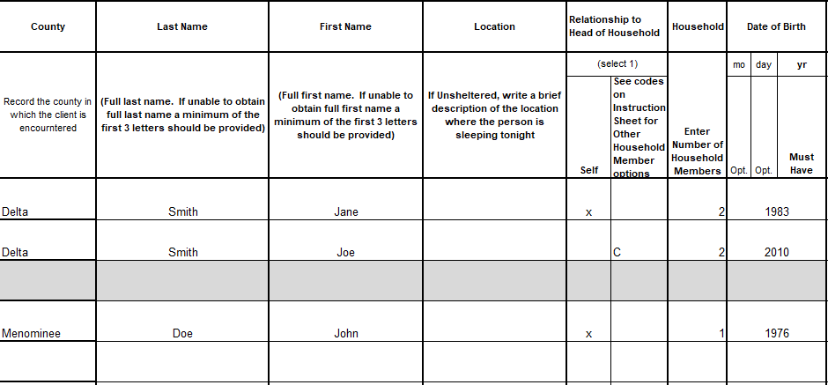

**Survey Questions and Instructions for Domestic Violence (DV) Agencies**

The 2005 Violence Against Women Act (VAWA) prohibits domestic violence agencies from entering and storing personally identifiable information (PII) in a shared electronic database. HUD strongly encourages the safe participation of DV Shelters in compliance with VAWA regulations in the annual PIT count. The following instructions have been developed to allow DV Shelters to participate in the PIT count in a manner that is compliant with VAWA regulation. Use the methods described below to document residents in shelter and TSH units on the PIT count survey.

In some communities, especially very small ones, even when not using the client’s name certain factors such as household size, race, and/or disabling conditions could inadvertently identify an individual. In cases where you feel the combination of information requested could reveal a client’s identity it is recommended you select one of the following options:

|  |  |
| --- | --- |
| **8** | Client Does not Know |
| **9** | Client Prefers Not To Answer |
| **99** | Data Not Collected |

**County:** Record the county in which the client is encountered or sheltered.

**Name:** Record the name of each Head of Household or Single Adult fleeing a DV situation as Anonymous 1, Anonymous 2, Anonymous 3, etc. in the Last Name Column.

For each additional Household Member: The Last Name field should be the same as the Head of Household (Anonymous 1, Anonymous 2, etc.). The First Name field will indicate the relationship to the Head of Household (Child 1, Child 2, etc.). See sample

below.

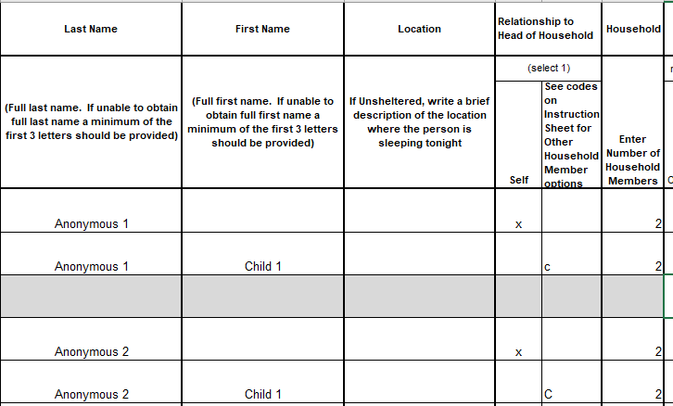

**Location:** Leave blank, for unsheltered only.

**Relationship to Head of Household:** Mark “Self” for single adult or the head of household. Only one person per household can be defined as “Head of Household.” For other household members use the following codes.

|  |  |
| --- | --- |
| **Code** | **Relationship** |
| **C** | Child |
| **OR** | Other Relation to Head of Household |
| **Other** | Other Non-Relations to Head of Household |

**Household:** Enter the number of individuals surveyed in the household. This number will be the same for all household members. Ex: If a household consists of 3 members, each household member would have a “3” in this section.

**Date of Birth:** Please enter either the age or age range code in the “Year” column.

|  |  |  |  |
| --- | --- | --- | --- |
| **Code** | **Age Range** | **Code** | **Age Range** |
| **1** | Ages 0 to 5 | **5** | Ages 24 to 44 |
| **2** | Ages 6 to 11 | **6** | Ages 45 to 54 |
| **3** | Ages 12 to 17 | **7** | Ages 55 to 64 |
| **4** | Ages 18 to 23 | **8** | Ages 65+ |

**Gender:** Please use the following codes to indicate which gender the client identifies as.

|  |  |
| --- | --- |
| **Code** | **Gender** |
| **M** | Man (Boy if Child) |
| **W** | Woman (Girl if Child) |
| **CS** | Culturally Specific Identity |
| **TG** | Transgender |
| **NB** | Non-Binary |
| **Q** | Questioning |
| **DI** | Different Identity |
| **8** | Client Doesn’t Know |
| **9** | Client Prefers Not To Answer |
| **99** | Data Not Collected |
|  |  |

**Race and Ethnicity:** Enter the race and ethnicity as identified by the individual during the count. If collecting information on a person with multiple responses separate each race using a comma. (ex: White, Asian). Use the following to indicate which race and ethnicity categories the client identifies as:

|  |  |
| --- | --- |
| **Code** | **Race** |
| **A** | American Indian, Alaskan Native, or Indigenous |
| **B** | Asian or Asian American |
| **C** | Black, African American, or African |
| **D** | Hispanic/Latina/e/o |
| **E** | Middle Eastern or North African |
| **F** | Native Hawaiian or Pacific Islander |
| **G** | White |
| **DK** | Client Doesn’t Know |
| **R** | Client Prefers Not To Answer |
| **DNC** | Data Not Collected |

**Domestic Violence Survivor:** Enter ‘Y’ for all persons in your DV Shelter and/or TSH Program.

**If Yes, Currently Fleeing:** Enter ‘Y’ for all persons in your DV Shelter and/or TSH Program.

**Approximate Date This Episode of Homelessness Started**: Use this section to enter the date (month/year) that the client entered the shelter or TSH program.

**Homeless Episodes in the Last 3 Years**: Enter the number of times the client has been homeless in the past 3 years.

You may also enter:

|  |  |
| --- | --- |
| **8** | Client Doesn’t Know |
| **9** | Client Prefers Not To Answer |
| **99** | Data Not Collected |

**Number Months Homeless in the Past 3 Years:**  If the client shares, they have been homeless in the past 3 years ask them to estimate how many months they were homeless each time. If the individual reports that they were homeless for one or more days in a given month, the individual is considered homeless that month.

You may also enter:

|  |  |
| --- | --- |
| **8** | Client Doesn’t Know |
| **9** | Client Prefers Not To Answer |
| **99** | Data Not Collected |

**Long-Term Disability:** Does the client have a disability that is considered long-term? Indicate “Yes” or “No” here. You can also enter “No” if this is information the client does not want to answer. A long-term disability may include: Physical Disability, Mental Disability, Developmental Disability, Substance Abuse Issues, Alcohol Abuse Issues, HIV. You may also enter:

**Sub-Populations**

**Disability:** Definitions of sub population disability choices (**Note:** Not all possible disabilities are listed here. A client may have a “Long-Term Disability” and not be included in this sub-population section) If a client does not want to reveal their condition all these columns can be left blank.

|  |  |
| --- | --- |
| **Code** | **Disability** |
| **AA** | Persons reported episodes of alcohol abuse |
| **SA** | Persons reported episodes of Substance Abuse - gets recorded in HMIS as drug abuse (Note: if both AA and SA are Checked, record as Both Alcohol and Drug Abuse) |
| **HIV** | Persons with the Human Immunodeficiency Virus |
| **MI** | Persons reported a diagnosis of a Mental Illness |
| **8** | Client Doesn’t Know |
| **9** | Client Prefers Not To Answer |
| **99** | Data Not Collected |

**Veteran Status**: Indicate the client’s veteran status here. This population category includes adults who have served on active duty in the Armed Forces of the United States. This does not include inactive military reserves or the National guard unless the person was called up to active duty.

**If client is a veteran,** please check the corresponding box that represents type of service.

**If not a veteran**, leave this section blank.

If you have any questions about the material covered in this workflow, please contact the MCAH help desk at [mihelp@mihomeless.org](mailto:mihelp@mihomeless.org) (MI) or [nchelp@nchmis.org](mailto:nchelp@nchmis.org) (NC).